
UKSEDS Monthly Report: February

Competition: <ORT >
Team Name: LAIKA
Date: <02 / 03 / 2026>

Progress Since Last Report:

On the mechanics side of the rover, we have calculated the required RPM and torque for the motors, as well as the appropriate dimensions for the wheels and wheelbase. These dimensions were calculated based on the necessity that the rover must be able to move across the sand without rolling on its side.

With these calculations, an initial design of the rover framework has been made, and the electronics team has researched and selected a DC motor (FIT0492-B) that fits our requirements. At the same time Power System parameters were approximated and the primal version of Power electronics was created. Motor Control Electronics sets were analysed and added for comparison. Controller of STM32 series and Raspberry Pi 4B are clarified to be used.

We have procured sand from the university architecture department to further test our rover's manoeuvrability and sample extraction in the approximated competition environment. We are drying the sand to mimic the competition and test, as well as the terrain on Mars.

Mechanical team made the research of usage of the Archimedes screws for sand collection and proceeded a few tests with prototypes, screws with screw angle more or equal to 30° didn’t work within tested rpms and attack angles, meanwhile the screw with less angle proceeded moderately successful, however mechanical team is considering switching to the conveyer or scoop-manipulator designs, to consider so a new series of tests will be procced.

Goals for Next Month: In bullet points, describe goals you will focus on in the next month

- Mechanics – mechanical layout of sand extraction. Design of wheelbase, suspension system, and wheels. Final design of rover frame.
- Software – software architecture (with and without ROS), STM32+RP+Camera+Laptop dataflow
- Electronics – Schematic of the power and the digital aspects of the rover
- System/Team – Process of integration of these components and calculations, purchase lists and orders, meanwhile develop the CDR.

- Appendix:

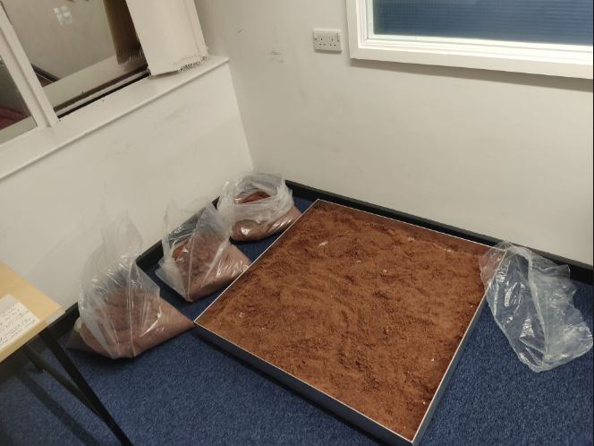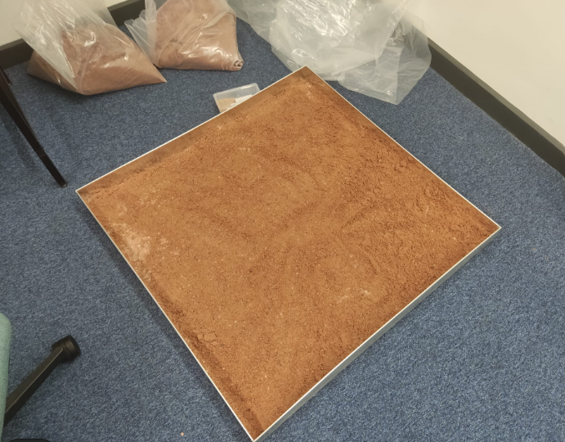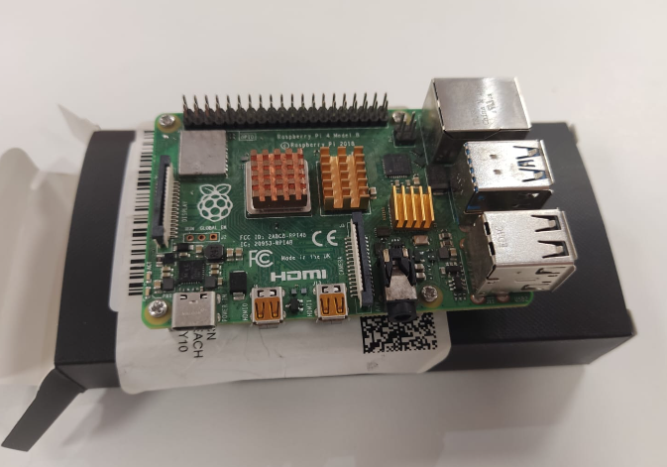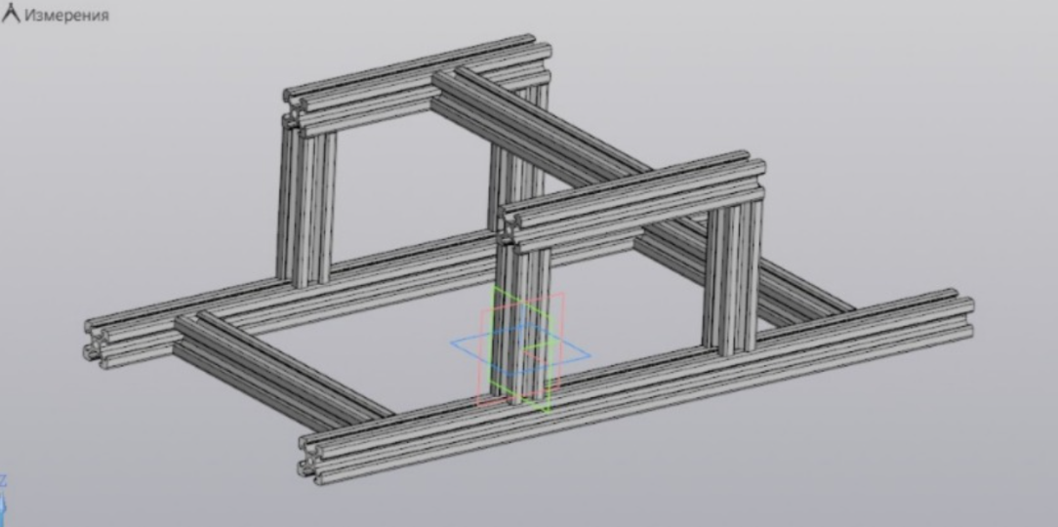
Initial design of Rover Framework
Raspberry Pi 4
Sand Layer 2
Sand Layer 1

